**



WORK IMMERSION PORTFOLIO

*(based on DepEd Order No. 30 s. 2017)*

This belongs to:

Name of Student-Trainee

Track / Strand / Section

Agency / Company / Cooperative

School Year

# PREFACE

#### Rationale

This Work Immersion Portfolio will serve as a workbook for the students who will take up the course/subject Work Immersion in Senior High School. The framework is based on DepEd Order No. 30 s. 2017, entitled Guidelines for Work Immersion.

This workbook will essentially foster in-depth learning of the world of work and assessment of student’s performance during work immersion.

Furthermore, the purpose of this portfolio includes but is not limited to the following:

***For Student-Trainees:***

* The portfolio will be used as a source of motivation and guide for work immersion.
* This will serve as a documentation and approval of lessons learned.
* This will provide feedback of their performance level.
* This will pave the way in preparation for real job application.

***School:***

* This contains regulations and conditions regarding contract between school and student.
* This is an information about curriculum and record of lessons learned.
* This is a record of student-trainees performance for assessment.

***Agency / Company:***

* This contains introduction of company in general.
* This enumerates training rules and regulations for training inside the agency/company.
* This provides feedback to and from student-trainees.

# WORK IMMERSION

**Grade:** 12 **No. of Hours:** ____ hours

**Pre-requisite:** Should have taken at least 4 Specialized Subjects

#### Course Description:

Work Immersion is one of the course requirements for graduation. A Senior High School student has to undergo Work Immersion in an industry that directly relates to the student’s postsecondary goal. Through Work Immersion, the students are exposed to and become familiar with work-related environment related to their field of specialization to enhance their competence. Specifically, the students are able to: (i) gain relevant and practical industrial skills under the guidance of industry experts and workers; (ii) appreciate the importance and application of the principles and theories taught in school; (iii) enhance their technical knowledge and skills; (iv) enrich their skills in communications and human relations; (v) develop good working habits, attitudes, appreciation, and respect for work. These prepare them to meet the needs and challenges of employment or higher education after graduation.

#### Duties and Responsibilities of the Learner

In this course, the learners are expected to:

1. Attend Pre and Post Immersion Activities;
2. Report to the Work Immersion Partner Institution Supervisor during actual immersion;
3. Perform the duties and tasks as indicated in the prescribed template for work immersion list of tasks/activities; and
4. Prepare the documentations and reports required in the curriculum and by the Partner Institution.

#### Assessment

The Work Immersion Teacher and the Work Immersion Partner Institution Supervisor will jointly assess the learner’s performance following the DepEd Order No. 8, s. 2015 *Policy Guidelines on Classroom Assessment for the K to 12 Basic Education Program.*

# STUDENT INFORMATION SHEET

Name :

*Insert 2 x 2 Picture*

Date of Birth :

Place of Birth :

Parent’s / Guardian’s Name :

Postal Address :

E-mail Address :

Cellphone Number :

Religion :

Health Issues / Allergies :

Hobbies / Past Time Activities : Skills / Talents :

Extra-curricular Activities in School : Support group / home companions : List your favourites :

One word or object that describes yourself : How do you feel about school? :

What are your most memorable subject / class? Why? :

What are your plans after Senior High School? :

What is your career path? :

What is your philosophy in life? :

Do you have plans to go abroad? If yes, where and why? :

What are your dreams and ambitions? :

How do you plan to achieve your ambitions and goals in life? :

What are your expectations and apprehensions for work immersion? :

Republic of the Philippines

**DEPARTMENT OF EDUCATION**

Region VII – Central Visaya

*Insert School Logo*

DIVISION OF CEBU CITY

**MABOLO NATIONAL HIGH SCHOOL**

## REQUEST FOR WORK IMMERSION

Sir / Madame:

This is to request permission from your good office to please allow , a Senior High School - Grade 12 student, to undergo a **80** hours of **WORK IMMERSION** in your company/agency to acquire industrial **ORIENTATION**. The training period will start immediately upon your acceptance of the bearer under the terms and conditions as stipulated in the duly accomplished memorandum of agreement hereto attached for your confirmation.

Moreover, a student evaluation is provided where a student is to be assessed on his/her performance, attitude and behaviour to be attested by the supervisor. The Immersion Teacher and Trainer handling each field of specialization from our school will visit your establishment from time to time to find out how the student perform in the working area.

Thank you very much for your usual cooperation and assistance extended to the school.

## ENDORSEMENT LETTER

Sir / Madame:

This is to introduce, , who is a grade 12 Senior High School student enrolled in our school under the K to 12 program with Strand in , and to further endorse (his/her) application with your company to undergo WORK IMMERSION for 80 hours as a requirement of the curriculum for graduation. We believe that schools must link up with industry in order to update, upgrade and make the education of our youth more relevant to the actual needs of the industry. It is in this regard that we request you to give such opportunities to our students by allowing them to do part time work with your company. Together with this letter is an Acceptance Form.

We request that said form be accomplished and returned to this office upon acceptance of our student in your company. We are confident that given the opportunity, our student will be an asset to your company.

Thank you for the favourable action and we look forward to a more fruitful linkage with you.

Very Truly Yours,

Noted:

**_____________________________________**

*Work Immersion Teacher*

## PRE- IMMERSION

**Introduction**

Before we immerse into the workplace we will first understand the immersion process, proper work ethics, workplace safety, confidentiality, and effective conflict resolution and teamwork skills, as agreed in the DepEd Order No. 30 s. 2017. Also, we need to hone our skills in writing a resume, filling of application forms, and complying requirements.

**Learner’s Activity**

1. Attends the pre-immersion orientation
2. As one to join the workforce in the future, you will need to do, prepare and secure the following:
   * Resume
   * Essay on how to conduct oneself inside the company establishment during the immersion period
   * Application letter
   * Clearance documents such as
     + *Medical certificate*
     + *Barangay Clearance*
     + *Police Clearance*
     + *Mayor’s Clearance*
   * Certificates for required trainings and seminars
   * Job Interview Skills Training

You will also prepare and accomplish own portfolio and update it from time to time because at the end of the work immersion you will need to present this portfolio. Make sure to attach needed documents, answer reflection leaf and paste pictures. Happy working ☺!

#### ECHOES and PONDER

**ACTIVITY 1 | The Worker**

Work is on your way. Are you prepared to work? Do you have the potential, character, talents, and skills to take up the vigour of being a worker? What should you possess to become a good worker? How will you prepare for work immersion?

### ACTIVITY 2

After the pre-immersion orientation, list the Do’s and Don’ts employed in the workplace you are assigned.

|  |  |
| --- | --- |
| **DO’s** | **DON’Ts** |
| 1. |  |
| 2. |  |
| 3. |  |
| 4. |  |
| 5. |  |
| 6. |  |
| 7. |  |
| 8. |  |
| 9. |  |
| 10. |  |
| 11. |  |
| 12. |  |
| 13. |  |
| 14. |  |
| 15. |  |

**Reflection**

1. **Do you agree to the company’s policy guidelines, rules and agreement? Support your answer.**
2. **Was there a rule that you think is not acceptable to you? Why?**

**ACTIVITY 3 | Situational Analysis**

# CONFIDENTIALITY IN THE WORKPLACE

Suppose you work in a police station or a law firm and signed a confidentiality agreement regarding all their cases at hand, suddenly your friend who was a suspect to a crime asked you for some documents that are in your office’s possession that may help him in his case. How would you deal with the situation?

#### ECHOES and PONDER

**ACTIVITY 4 | Conflict Resolution**

Did you ever experience disagreement and conflict with co-workers? How did you handle the situation? How would you rate your skills in handling differences of opinion? Please give an example that illustrates that skill.

***Please attach your resume here.***

***Sample Resume***

## MIKHAEL HOSNI C. SIMBAN

Home Address : Zone 4 Taboc, Opol, Misamis Oriental Cellphone Number : 09756438084

E-mail Address : [khaeljibby@gmail.com](mailto:khaeljibby@gmail.com)

Date of Birth : September 1, 1999

Gender : Male

Field of Training : Culinary Arts

|  |  |
| --- | --- |
| **EDUCATION** | **YEAR GRADUATED** |
| **OPOL NATIONAL SECONDARY TECHNICAL SCHOOL**  *Senior High School* | in progress (2019) |
| **BAGOCBOC NATIONAL HIGH SCHOOL**  *Junior High School* | 2017 |
| **OPOL CENTRAL SCHOOL**  *Elementary School* | 2013 |

|  |  |
| --- | --- |
| Field of Study | TVL major in Cookery |
| Relevant Work Experience | Cashier at Phil’s General Merchandise (Summer of 2017) |
| Skills / Qualifications | **Computer Skills:**  *Well verse in Microsoft Word, Microsoft Excel, and Microsoft PowerPoint*  **NCII Certificate:**  *Proficient in Food and Beverage Services, Commercial Cooking, Bread and Pastry* |
| Special Awards / Honors / Certificates | * Perfect Attendance Awardee SY. 2017-2018 * With Honors Awardee SY. 2017-2018 * Loyalty Awardee SY. 2016-2017 |
| Activities & Interests | * Restaurant Skills *(setting tables and chairs; inventory check- up; wine serving)* * Kitchen Skills *(proper hygiene and food handling)* * Front Office Skills *(proper procedure for guests accepting reservation, check-in and check-out)* |

***Place your application letter here***



***Sample Application Letter***

**MIKHAEL HOSNI C. SIMBAN**

Zone 4 Taboc, Opol, Misamis Oriental [khaeljibby@gmail.com](mailto:khaeljibby@gmail.com)

Cellphone No. 09756438084

September 12, 2018

**ARTHUR S. NONAME**

*HRD Manager*

Any Kitchen Company Cagayan de Oro City

Dear Sir,

I would like to apply for the post of Cook which you have advertised in the local news *Pamahaw Espesyal* on August 30, 2018.

I believe I meet all the requirements listed in your advertisement. As a NCII holder in Cookery, Food and Beverage Services, and Bread and Pastry, I have deep knowledge regarding culinary products and services. I understand all aspects of kitchen operations in areas of menu planning, purchasing, kitchen safety, recipe development, food cost analysis, and quality control. I can cook various dishes, including traditional, national, and international cuisines.

For your further consideration, I have good communication skills as well as computer and internet skills. I am a hardworking person, able to work well under pressure as an individual and as a part of a team, creative, detail-oriented, pleasant and convenience in dealing with people.

Thank you very much for your attention. I am looking forward to hear from you soon.

Yours Truly,

**MIKHAEL HOSNI C. SIMBAN**

SHS Work Immersion Portfolio Page 12

Give the process and fees required for a BARANGAY CLEARANCE. Attach also your BARANGAY CLEARANCE.

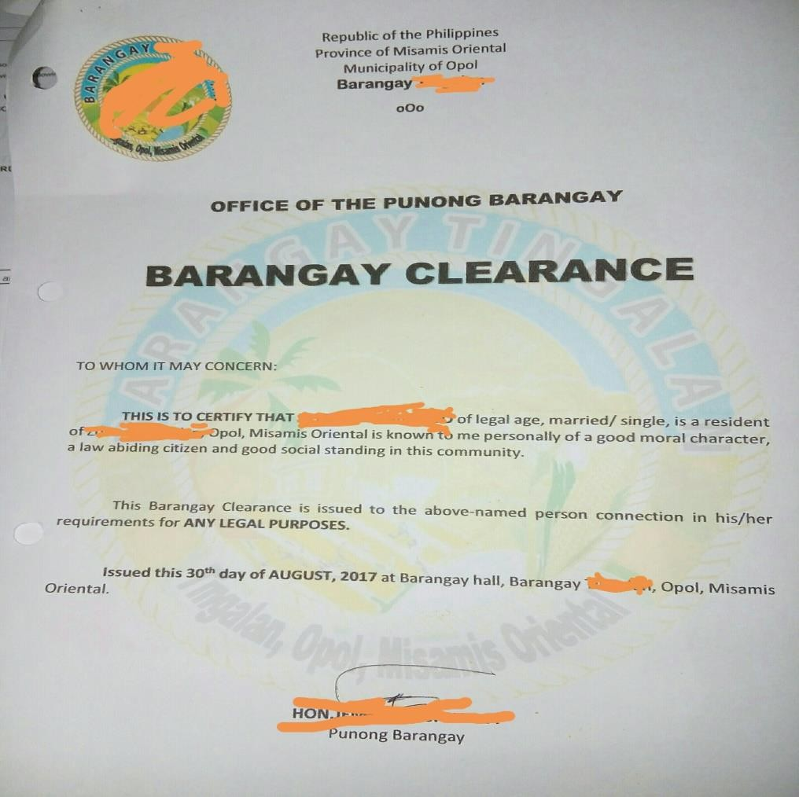

* 1. Steps in securing barangay clearance

1.

2.

3.

4.

5.

* 1. Attach Barangay Clearance

***Sample***

SHS Work Immersion Portfolio Page 13

Give the process and fees required for a POLICE CLEARANCE. Attach also your POLICE CLEARANCE.

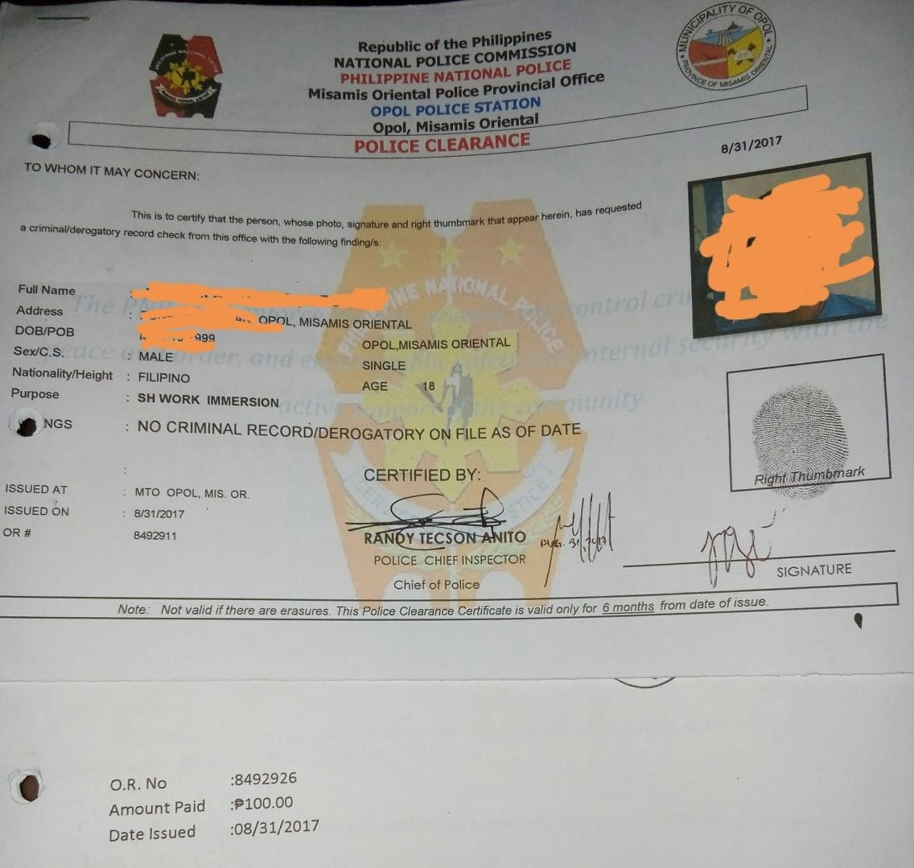

1. Steps in securing Police Clearance

1.

2.

3.

4.

5.

1. Attach Police Clearance

***Sample***

SHS Work Immersion Portfolio Page 14

Give the process and fees required for a MAYOR’s CLEARANCE. Attach also your MAYOR’s CLEARANCE.

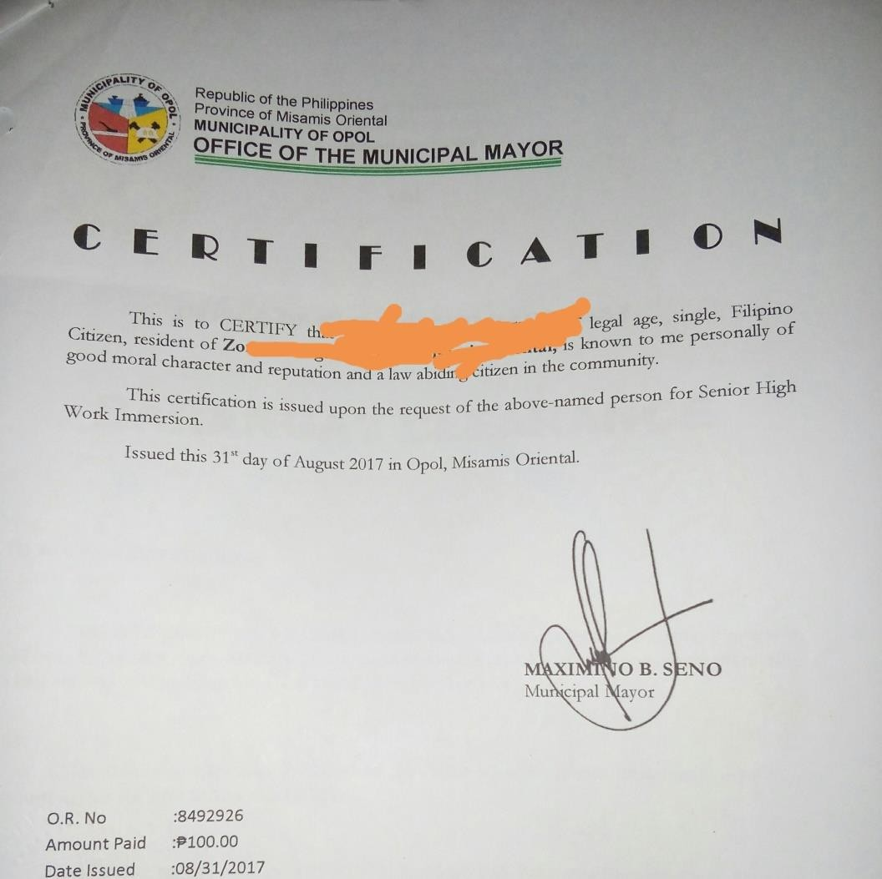

1. Steps in securing Mayor’s Clearance

1.

2.

3.

4.

5.

1. Attach Mayor’s Clearance

***Sample***

SHS Work Immersion Portfolio Page 15

Give the process and fees required for a MEDICAL CERTIFICATE. Attach also your MEDICAL CERTIFICATE.



1. Steps in securing Medical Certificate

1.

2.

3.

4.

5.

*Please attach your MEDICAL CERTIFICATE here.*

***Sample***

Department of Education Region X

**Sample**

Division of Misamis Oriental

## MEDICAL CERTIFICATE

**To Whom It May Concern:**

This is to certify that I have personally examined , age , sex , born on

and have found that he/she is physically fit , during the time of examination, to do the work immersion at Opol LGU.

**Physical Examination**

Date examined: :

Height: : Weight : Blood Pressure : Pulse, Resting : Respiratory Rate :

Other Remarks :

|  |  |  |  |
| --- | --- | --- | --- |
| **Other Findings** | **Yes** | **No** | **If Yes, please specify** |
| Asthma |  |  |  |
| Food Allergy |  |  |  |
| Undergone Operation |  |  |  |
| Kidney Infection |  |  |  |
| Heart Ailment |  |  |  |
| Others |  |  |  |

Medical Officer

*For Work Immersion Only*

SHS Work Immersion Portfolio Page 16

### ACTIVITY 11 | JOB INTERVIEW

A job interview is an interview consisting of a conversation between a job applicant and a representative of an employer which is conducted to assess whether the applicant should be hired. How you answer questions during job interview can have a big impact on you being hired or accepted as a work immerse. Jot down questions that you have come across during your first dialogue with the partner-industry work supervisor or head of office you will be assigned.

## MOCK JOB INTERVIEW

Here are some questions that you may encounter during an interview. Try answering them.

**Interpersonal Skills**

1. What are your strengths? What are your weaknesses?
2. What do you do when you know you are right and your boss disagrees with you? Give me an example.
3. If your colleagues had an opportunity to tell us your primary strength what would that be? And, your primary weakness-what would that be?
4. As a component of this position, you may have to work on a team on certain projects. Describe when you’ve worked on a team before and what, in your opinion, constitutes an effective team? What do you expect from others on the team and what do you need from others on the team?
5. What do you do when others resist of reject your ideas or actions?

**Behavioural**

1. Suppose you are in a situation where deadlines and priorities change frequently and rapidly. How would you handle it?
2. How do you know when you are stressed? What do you do to de-stress?
3. Tell me about a time when you were a part of a great team. What was your part in making the team effective?
4. Suppose your supervisor asked you to get information for them that you know is confidential and he/she should not have access to. What would you do?
5. Describe a time when you performed a task outside your perceived responsibilities. What was the task? Why did you perceive it to be outside your responsibilities? What was the outcome?

**Creative Thinking**

1. What’s the best book you’ve read in the last year? Please take a minute and tell us what you liked about it.
2. What was the most creative thing you did in your last job?
3. What is your interpretation of “success?”
4. Describe an ideal work environment or “the perfect job.”
5. In what way(s) do you express your personality in the workplace?

**Leadership**

1. How would you describe an ideal supervisor?
2. What strengths did you rely on in your last position to make you successful in your work?
3. As a supervisor, it is essential to motivate employees in your area. Sometimes this must be done using non-monetary means. Please describe some creative ways you have motivated and recognized employees in the past non-monetarily.
4. Explain, step by step, how you have coached an employee who had performance problems.
5. If you had to describe your own leadership style as directive, delegating, or coaching, which would you choose? Please explain why giving examples.

**Optional Situational Questions:** *Please explain how you would handle the following situations:*

1. You observe two of your employees arguing in a central location in the office.
2. One of your employees comes to you complaining about another employee and insisting they should no longer work together.
3. One of your employees comes to you to complain that he/she has a more demanding work load than another employee and wants the workload to be shifted.

**General**

1. Could you share with us a recent accomplishment of which you are most proud?
2. Tell us a bit about your work background, and then give us a description of how you think it relates to our current opening.
3. Why have you applied for this position?
4. What skill set do you think you would bring to this position?
5. Tell me about your present or last job. Why did you choose it? Why did you/do you want to leave?
6. What was your primary contribution/achievement? Biggest challenge?
7. What are your short-term and long-term goals?
8. In what areas would you like to develop further? What are your plans to do that?
9. What are some positive aspects of your last employment/employer? What are some negative aspects?
10. What do you know about our company?
11. Why should we hire YOU?
12. After learning about this opportunity, what made you take the next step and apply for the job?
13. If you are the successful applicant, how would you expect to be different after a year in this position?
14. Now that you have learned about our company and the position you are applying for, what hesitation or reluctance would you have in accepting this job if we offer it to you?

#### ECHOES and PONDER

**ACTIVITY 12 | Mock Job Interview**

**During the conduct of the mock job interview, do you think you did well?**

**What are the areas that you think you are good at and areas that needed to be improved?**

**Are you more confident now to answer during job interview?**

## IMMERSION PROPER

Dear student you are now nearing your immersion proper. Before the immersion proper please ensure that you have a signed parent’s permit and kindly attach your insurance policy here.

#### ACTIVITY 13 | Attach Insurance Policy here

***Sample***

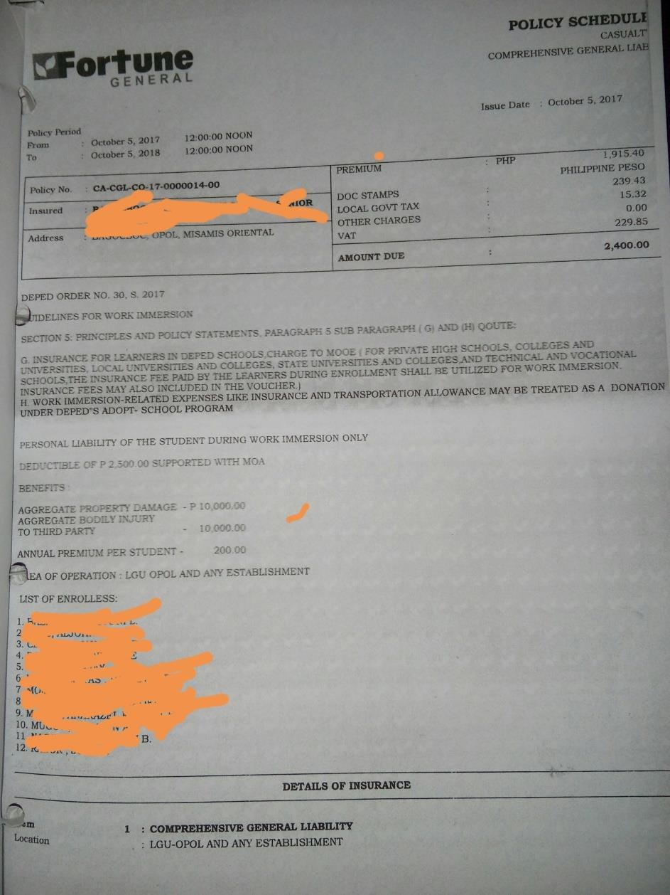

#### ACTIVITY 14 | Parents’ Consent Form



A parent’s consent form is a document signed by parents or legal guardians that grants permission for a student to undergo Work Immersion.

***Attach Parents Permit here***

|  |  |  |
| --- | --- | --- |
| Consent Form  **WORK IMMERSION** | | |
| Name of School |  | |
| Date of Birth |  | |
| School |  | |
|  | | |
| Name of Parent/Guardian |  | |
| Address |  | |
| Contact Number |  | |
| **MEDICAL BACKGROUND** | | |
| Does your child suffer from any medical conditions/allergies? (please check appropriate box)  □ Yes □ No | | |
| *Please provide details of medication that must be administered, if any:* | | |
| **UNDERTAKING:**   1. I agree to my son/daughter taking part in the Work Immersion as a key feature of the Senior High School Curriculum, which involves hands-on experience or work simulation in which learners can apply their competencies and acquired knowledge relevant to their track; 2. I understand that an insurance for learners in DepEd schools shall be procured by their respective schools, hence, I hereby release the school, its teachers and personnel from any and all liability, claims, demands, and causes of action whatsoever arising out of or related to any loss, damage or injury that may be sustained by my son/daughter during the Work Immersion: 3. I confirm to the best of my knowledge that my son/daughter does not suffer from any medical condition other than those listed above; 4. That I have read and fully understood the statements above including the implications thereof. | | |
| *Signature Over Printed Name of Parent/Guardian* | | Date: |

SHS Work Immersion Portfolio Page 22

# THE COMPANY



I. **Objectives:** Appreciating management processes by observing, identifying and describing the following:

1. Nature of the business
2. Description of the products/services
3. Target clientele
4. Organizational structure
5. Company rules and regulations

#### ACTIVITY 15 | Profile of the Company/Establishment

***Sample Company Profile***

Owner Johanna Shandy served as a pioneer of cultural gentrification when she opened the café nearly a decade ago. Her father established the family’s business in Palao Market about 30 years ago. Johanna runs the café with her 2 sons. The café has 10 employees and seats 50 in its 60 meter location. Menu offers freshly baked pastries and desserts, homemade pastas, breakfast, salads and various gourmet main courses like the famed Boullabaise dish.

**Write description and profile of your work immersion area. Please include pictures.**

**______________________________________________________________________________________________________________**

**_______________________________________________________________________________________________________________________**

**_______________________________________________________________________________________________________________________**

**_______________________________________________________________________________________________________________________**

**_______________________________________________________________________________________________________________________**

**___________________________________________________________________________________ Vision**

*Insert Company Picture*

**Mission**

**Objectives**

*Insert Company Picture*

**Core Values**

SHS Work Immersion Portfolio Page 23

#### ACTIVITY 16 | Organizational Chart

An organizational chart is a graphic representation of the structure of an organization, showing the relationships of the positions or jobs within it.

*Attach or draw the organizational chart of the office or establishment you are assigned for work immersion. Below is a sample*

***Sample Organizational Chart of a Restaurant***

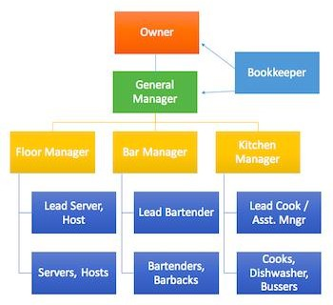

#### ACTIVITY 17 | Company Rules and Regulation

Describe briefly and/or insert or paste here.

**______________________________________________________________________________________________________________**

**_______________________________________________________________________________________________________________________**

**_______________________________________________________________________________________________________________________**

**_______________________________________________________________________________________________________________________**

**_______________________________________________________________________________________________________________________**

**_______________________________________________________________________________________________________________________**

**_______________________________________________________________________________________________________________________**

**______________________________________________________________**

##### WORK IMMERSION AGREEMENT AND LIABILITY WAIVER

I am fully aware of the duties and responsibilities I will undertake through the **Work Immersion Program** with the cooperating company through the request of

.

I recognize the authority of my cooperating company which I may be placed and submit myself to all the **Rules and Regulations** that may be imposed upon myself following the duties.

I renounce and waive any claim against the cooperating company and

for any injury that I may sustain/suffer, personal/financial in the performance of my duties/function.

**Name of Student-Trainee**:

**Signature**:

**Date**:

##### PARENTAL / GUARDIAN’S CONSENT

And I, the trainee’s parent and/or legal guardian, allow my son/daughter to undergo Work Immersion for **80** hours starting on until at

in partial fulfilment of the requirements for Senior High School K-12 Program.

It is understood that he/she abides by the **rules and regulations** that may be imposed by the Supervisor/Staff-in-Charge for his/her welfare and safety.

I fully agree to waive any responsibility on the part of in case of any untoward incident that may happen to my son/daughter during the duration of the WORK IMMERSION.

**Name of Student-Trainee**:

**Signature**:

**Date**:

#### ACTIVITY 18 | Work Immersion Task/s Activities



Attach signed Annex C

***Sample***

**List of Tasks/Activities to be done during Work Immersion** *(may change according to track/strand)*

|  |  |  |  |
| --- | --- | --- | --- |
| Name of Student |  | Grade & Section |  |
| School Name |  | Immersion Site |  |
| Track |  | Strand/Specialization |  |
| Duration of Work Immersion |  |  | |

|  |  |  |  |
| --- | --- | --- | --- |
| School Partnerships Focal Person |  | Contact Number |  |
| Work Immersion Teacher |  | Contact Number |  |

|  |  |  |  |  |
| --- | --- | --- | --- | --- |
| **COMPETENCIES** | **TASKS/ACTIVITIES** | **TIME ALLOTMENT** | **ACTUAL SCHEDULE** | **REMARKS** |
| OBSERVE PROPER WORK ETHICS | The student:   * Be at the workplace 10-15 minutes before the time; * Follow instructions carefully from the direct supervisor; * Observe and follow rules and regulations of the workplace / industry; * Know and perform your duties and responsibilities accordingly; * Observe and practice confidentiality in the   workplace/industry; and Observe and practice working with the team. |  |  |  |
| SAFETY IN THE WORKPLACE | * Do exactly as directed by your immediate supervisor; * Be observant of the do’s and don’ts of the workplace   /industry; and   * Know and practice your bounds/limits as per instruction by your immediate supervisor. |  |  |  |
| SENSITIVITY TO CULTURES AND PRACTICES | * Be observant and respectful of the different cultures and practices of your clients, supervisors and co- workers; * **ALWAYS** respect people in authority ,co-workers and clients; and * Think before talking about culture and religion. |  |  |  |
| FILING AND ARRANGING OF DOCUMENTS | * File and arrange documents as per instruction by the immediate supervisor; and * Encode the data’s gathered from survey as directed by the immediate supervisor. |  |  |  |
| EVALUATING THE WORK IMMERSION | * Present portfolio with the week diary entries; * Compare and contrast school and work application of skills, knowledge and attitudes; * Write an updated resume reflecting your Work Immersion experience; and * Reflect and write about your Work Immersion experience. |  |  |  |

Students shall not be given other activities outside of those previously agreed upon, which are anchored on the stated competencies.

Certified True and Correct:

|  |  |  |
| --- | --- | --- |
| *Student’s Signature Over Printed Name* |  | *Parent’s Signature Over Printed Name* |
| *Work Immersion Teacher’s Signature*  *Over Printed Name* |  | *Industry Supervisor’s Signature Over*  *Printed Name* |

SHS Work Immersion Portfolio Page 26

#### ACTIVITY 19 | Report on Activities Performed



*State the work functions delegated unto you and how you accomplished it.*

|  |  |  |
| --- | --- | --- |
| **DATE** | **ACTIVITIES DONE** | **REMARKS** |
|  |  |  |
|  |  |  |
|  |  |  |
|  |  |  |
|  |  |  |

*Attach documents or pictures*

SHS Work Immersion Portfolio Page 27

#### ACTIVITY 20 | Business Flow Chart



A business flow chart shows the steps that make up a business process, along with who’s responsible for each step. They are useful for analysing current processes, planning improvements, and crystallizing communication between process participants.

**Task:** *Draw a diagram of the company or institution’s business flow chart where you are assigned. Do ask permission from head of office before doing so.*

SHS Work Immersion Portfolio Page 28

*Attached signed DTR.*

#### ACTIVITY 21 | Civil Service Form No. 48

**DAILY TIME RECORD**

## ATTENDANCE SHEET

|  |  |  |  |  |
| --- | --- | --- | --- | --- |
| For the Month of: | | | | |
| Date | Time In | Time Out | No. of Hours | Remarks |
| 1 |  |  |  |  |
| 2 |  |  |  |  |
| 3 |  |  |  |  |
| 4 |  |  |  |  |
| 5 |  |  |  |  |
| 6 |  |  |  |  |
| 7 |  |  |  |  |
| 8 |  |  |  |  |
| 9 |  |  |  |  |
| 10 |  |  |  |  |
| 11 |  |  |  |  |
| 12 |  |  |  |  |
| 13 |  |  |  |  |
| 14 |  |  |  |  |
| 15 |  |  |  |  |
| 16 |  |  |  |  |
| 17 |  |  |  |  |
| 18 |  |  |  |  |
| 19 |  |  |  |  |
| 20 |  |  |  |  |
| 21 |  |  |  |  |
| 22 |  |  |  |  |
| 23 |  |  |  |  |
| 24 |  |  |  |  |
| 25 |  |  |  |  |
| 26 |  |  |  |  |
| 27 |  |  |  |  |
| 28 |  |  |  |  |
| 29 |  |  |  |  |
| 30 |  |  |  |  |
| 31 |  |  |  |  |

|  |  |  |  |  |
| --- | --- | --- | --- | --- |
| For the Month of: | | | | |
| Date | Time In | Time Out | No. of Hours | Remarks |
| 1 |  |  |  |  |
| 2 |  |  |  |  |
| 3 |  |  |  |  |
| 4 |  |  |  |  |
| 5 |  |  |  |  |
| 6 |  |  |  |  |
| 7 |  |  |  |  |
| 8 |  |  |  |  |
| 9 |  |  |  |  |
| 10 |  |  |  |  |
| 11 |  |  |  |  |
| 12 |  |  |  |  |
| 13 |  |  |  |  |
| 14 |  |  |  |  |
| 15 |  |  |  |  |
| 16 |  |  |  |  |
| 17 |  |  |  |  |
| 18 |  |  |  |  |
| 19 |  |  |  |  |
| 20 |  |  |  |  |
| 21 |  |  |  |  |
| 22 |  |  |  |  |
| 23 |  |  |  |  |
| 24 |  |  |  |  |
| 25 |  |  |  |  |
| 26 |  |  |  |  |
| 27 |  |  |  |  |
| 28 |  |  |  |  |
| 29 |  |  |  |  |
| 30 |  |  |  |  |
| 31 |  |  |  |  |

Certified True and Correct:

|  |  |  |  |  |
| --- | --- | --- | --- | --- |
| *Signature Over Printed Name of*  *Student-Trainee* |  | *Work Immersion Teacher* |  | *Partner Institution’s Supervisor* |

**ACTIVITY 22 |Daily Task Record / Daily Journal**

A daily task record is a work log that summarizes how an employee spent his time on the job. Through a daily work log, an employee can create a mental picture of what comprises his day and how he uses his time. It is also helpful in understanding how productive an employee is during a particular period of the workday.

Accomplish your daily task record.

Department: Area: Date of Tracking Started: Date of Tracking Ended:

|  |  |  |  |
| --- | --- | --- | --- |
| **DAILY TASK** | **START** | **END** | **COMMENTS** |
|  |  |  |  |
|  |  |  |  |
|  |  |  |  |
|  |  |  |  |
|  |  |  |  |
|  |  |  |  |
|  |  |  |  |
|  |  |  |  |
|  |  |  |  |
|  |  |  |  |
|  |  |  |  |
|  |  |  |  |
|  |  |  |  |

Signed:

*Name and Signature of Student-Trainee*

Noted:

*Name and Signature of Supervisor*

#### ACTIVITY 23 | Work Performance Artefacts



Attach photos, illustrations, and other evidences *(e.g. certificates of awards received)* of performed hands-on skills that include knowledge of work and quality of work done.

SHS Work Immersion Portfolio Page 31

#### ACTIVITY 24 | Personal Traits 1



Attach photo, illustrations, and other evidences *(e.g. certificates of awards received)* of good personality traits demonstrated during the work immersion which is based on ***pleasing appearance, courtesy, conduct, industriousness, and reliability****.*

#### ACTIVITY 25 | Personal Traits 2

Attach photo, illustrations, and other evidences *(e.g. certificates of awards received)* of good personality traits demonstrated during the work immersion which is based on ***sociability, drive and leadership, mental maturity, and stress tolerance.***

SHS Work Immersion Portfolio Page 32

#### ACTIVITY 26 | Other Related Tasks



Other related tasks means taking on tasks outside your role but is based on the company given competencies to the students.

***Attach or write an account of other related tasks.***

SHS Work Immersion Portfolio Page 33

#### ACTIVITY 27 | Post- Immersion

Dear students you are now on the final stretch of your work immersion course. At this juncture you need to revisit the things that have been done in the past few days. What are the events that are memorable to you, what are the key learning’s that you have achieved and lastly you need to evaluate if the experienced gave you more confidence to face what lies ahead.

**Make a collage of your work experience**

#### Echoes and Ponder

**ACTIVITY 28**

## ACCOMPLISHMENT REPORT

**______________________________________________________________________________________________________________**

**_______________________________________________________________________________________________________________________**

**_______________________________________________________________________________________________________________________**

**_______________________________________________________________________________________________________________________**

**_______________________________________________________________________________________________________________________**

**_______________________________________________________________________________________________________________________**

**_______________________________________________________________________________________________________________________**

**_______________________________________________________________________________________________________________________**

**_______________________________________________________________________________________________________________________**

**_______________________________________________________________________________________________________________________**

**_______________________________________________________________________________________________________________________**

**_______________________________________________________________________________________________________________________**

**_______________________________________________________________________________________________________________________**

**_______________________________________________________________________________________________________________________**

**_______________________________________________________________________________________________________________________**

**_______________________________________________________________________________________________________________________**

**_______________________________________________________________________________________________________________________**

**_______________________________________________________________________________________________________________________**

**_______________________________________________________________________________________________________________________**

**_______________________________________________________________________________________________________________________**

**_______________________________________________________________________________________________________________________**

**_______________________________________________________________________________________________________________________**

**_______________________________________________________________________________________________________________________**

**_______________________________________________________________________________________________________________________**

**_______________________________________________________________________________________________________________________**

**_______________________________________________________________________________________________________________________**

**_______________________________________________________________________________________________________________________**

**_______________________________________________________________________________________________________________________**

**_______________________________________________________________________________________________________________________**

**_______________________________________________________________________________________________________________________**

**_______________________________________________________________________________________________________________________**

**_______________________________________________________________________________________________________________________**

**________________________________________________________________________________**

**MY UPDATED RESUME**

**WORK IMMERSION HIGHLIGHTS**

**MY REFLECTIONS**

How did the experience change me as a person, and how will it help me in the future.

**COMPLETION CERTIFICATE**

**COLLAGE OF MY SENIOR HIGH EXPERIENCE**

**ASSESSMENT**

The Work Immersion Teacher and the Work Immersion Partner Institution Supervisor will jointly assess the learners’ performance following the DepEd Order No. 8, s. 2015 *(Policy Guidelines on Classroom Assessment for the K TO 12 Basic Education Program).*

The Work Immersion Teacher shall then issue the Final Grade *(from DepEd Order No. 30, S. 2017, Section 8. Page 11 of 11).*

#### Performance Assessment Form

##### PRE-IMMERSION

**Objectives:** Understanding work immersion by discussing:

* 1. ***Expected Behaviour*** – Work ethics, Safety in the workplace, workplace rights and responsibilities, confidentiality in the workplace, effective conflict resolution and teamwork skills
  2. ***Appreciating the importance of credentials by:*** writing a resume, filling out application forms, secure clearances, job interview skills training

**Performance Indicator:**

(10) - Excellent (9) - Very Good (8) - Good (7) - Fair, (6) - Poor Performance

***\*To be rated by the Work Immersion Teacher and should be indicated in the Written Works 1***

|  |  |  |  |  |  |  |  |  |
| --- | --- | --- | --- | --- | --- | --- | --- | --- |
| **Competency** | **Activity No.** | **Task/Output/Artefact** | **Performance Rating** | | | | | **Rate** |
| *10* | *9* | *8* | *7* | *6* | **WI Teacher** |
| **A.** (example) |  | | | | | | | |
| Work ethics | 1 | The Worker (Essay) |  |  |  |  |  |  |
| Safety in the workplace | 2 | Do’s & Don’ts |  |  |  |  |  |  |
| Confidentiality in the workplace | 3 | Confidentiality in the Workplace |  |  |  |  |  |  |
| Effective conflict  resolution | 4 | Conflict Resolution |  |  |  |  |  |  |
| B. |  | | | | | | | |
| Writing a resume | 5 | Sample Resume |  |  |  |  |  |  |
| Filling out application forms | 6 | Application Letter |  |  |  |  |  |  |
| Secure clearances | 7  8  8  10 | Barangay, Police,  Mayor’s Clearance,  Medical Certificate |  |  |  |  |  |  |
| Job interview skills | 11 | Job Interview |  |  |  |  |  |  |
| Other documents | 12  13 | Insurance Policy Parent’s Consent |  |  |  |  |  |  |
| **Perfect Score: 130** |  | Total Raw Score |  | | | | |  |
| **Descriptor** |  | **Average** = *Total Raw*  *Score / No. of activities* |  | | | | |  |

**Feedback of Work Immersion Teacher:**

**______________________________________________________**

*Name and Signature of Work Immersion Teacher*

##### IMMERSION PROPER

* 1. **Objectives**: Appreciating management processes by observing, identifying and describing the following:
     1. Nature of the business;
     2. Description of the products/services;
     3. Target clientele;
     4. Organizational structure;
     5. Company rules and regulations

***Skills Indicator:*** (10) - Excellent (9) - Very Good (8) - Good (7) - Fair (6) - Poor Performance

***\*To be rated by the Work Immersion Partner Institution Supervisor and Work Immersion Teacher, to be indicated in the Performance Task 1***

|  |  |  |  |  |  |  |  |  |  |
| --- | --- | --- | --- | --- | --- | --- | --- | --- | --- |
| **Competency** | **Activity No.** | **Task/Output/Artefact** | **Performance Rating** | | | | | **Rate** | |
| *10* | *9* | *8* | *7* | *6* | *Supervisor*  *60%* | *Teacher*  *40%* |
| Nature of the business | 14 | Written narrative on company profile |  |  |  |  |  |  |  |
| Description of the products / services | 14 | Pictures of products / services or written narrative on activities  performed |  |  |  |  |  |  |  |
| Target clientele | 14 | Business profile |  |  |  |  |  |  |  |
| Organizational  structure | 15 | Organizational chart |  |  |  |  |  |  |  |
| Company rules  & regulations | 16 | Company handbook or  list of rules & regulations |  |  |  |  |  |  |  |
| **Perfect Score:** 50 | | **Total Raw Score** | | | | | |  | |
| **Descriptor** | | **Average** = Total Raw Score/ no. of activities | *Ex. 10/ Excellent* | | | | |  |  |

**What went well? _______________________**_________________________________________________________________

**What needs to be improved?**

**Feedback of Supervisor:**

*Name and Signature of Supervisor*

**Feedback of Work Immersion Teacher:**

**______________________________________________________**

*Name and Signature of Immersion Teacher*

* 1. **Objectives**: Appreciating business processes by observing and participating in Safety / Production

/ Maintenance / Quality Control / Quality Assurance / Customer Satisfaction / Housekeeping / Hygiene and others

***Skills Indicator:*** (10) - Excellent (9) - Very Good (8) - Good (7) - Fair (6) - Poor Performance

***\*To be rated by the Work Immersion Partner Institution Supervisor and Work Immersion Teacher, indicated in the Performance Task 2***

|  |  |  |  |  |  |  |  |  |  |
| --- | --- | --- | --- | --- | --- | --- | --- | --- | --- |
| **Competency** | **Activity No.** | **Performance Task/Output/Artefact** | **Performance Rating** | | | | | **Rate** | |
| *10* | *9* | *8* | *7* | *6* | *Supervisor 60%* | *Teacher 40%* |
| Safety / Production / Maintenance / Quality Control  / Quality Assurance / Customer Satisfaction / Housekeeping /  Hygiene and others | 17 | Written narrative on business processes of the  company *(may contain photos & charts)* |  |  |  |  |  |  |  |
| 18 | Written report on activities performed |  |  |  |  |  |  |  |
| 19 | Business process flow chart |  |  |  |  |  |  |  |
| **Perfect Score:** 30 | | Total Raw Score: | | | | | |  |  |
| **Descriptor** | | **Average** = Total Raw Score/ no. of activities | | | | | |  |  |

**What went well? _______________________**_________________________________________________________________

**What needs to be improved?**

**Feedback of Supervisor:**

*Name and Signature of Supervisor*

**Feedback of Work Immersion Teacher:**

*Name and Signature of Immersion Teacher*

* 1. **Objectives:** Applying skills learned and proper values acquired in school.

***Skills Indicator:*** (10) - Excellent (9) - Very Good (8) - Good (7) - Fair (6) - Poor Performance

***To be rated by the Work Immersion Partner Institution Supervisor and Work Immersion Teacher, to be indicated in the Performance Task 3***

|  |  |  |  |  |  |  |  |  |  |
| --- | --- | --- | --- | --- | --- | --- | --- | --- | --- |
| **Competency** | **Activity No.** |  | **Performance Rating** | | | | | **Rate** | |
| **Task/Output/Artefact** | 10 | 9 | 8 | 7 | 6 | Supervisor 60% | Teacher 40% |
| Applying skills learned and proper values acquired in school | 20 | Daily Time Record |  |  |  |  |  |  |  |
| 21 | Daily Task Record or Daily  Diary/ Journal |  |  |  |  |  |  |  |
| 22 | Photos, illustrations of performed hands-on skills  Work Performance *(includes knowledge and quality of work)* |  |  |  |  |  |  |  |
| 23 | Personal Traits 1 *(based on pleasing appearance, courtesy, conduct, industriousness, and*  *reliability)* |  |  |  |  |  |  |  |
|  | 24 | Personal Trait 2 *(based on sociability, drive and leadership,*  *mental maturity and stress tolerance)* |  |  |  |  |  |  |  |
|  | 25 | Other related tasks |  |  |  |  |  |  |  |
| **Perfect Score:** 60 | | **Total Raw Score** | | | | | |  |  |
| **Descriptor** | | **Average** = Total Raw Score / no. of activities | | | | | |  |  |

**What went well? _______________________**_________________________________________________________________

**What needs to be improved?**

**Feedback of Supervisor:**

*Name and Signature of Supervisor*

**Feedback of Work Immersion Teacher:**

**______________________________________________________**

*Name and Signature of Immersion Teacher*

##### POST WORK IMMERSION

* 1. **Objectives:** Evaluating the Work Immersion Experience

***Skills Indicator:*** (10) - Excellent (9) - Very Good (8) - Good (7) - Fair (6) - Poor Performance

***\*To be rated by the Work Immersion Teacher and should be indicated in the Written Works 2***

|  |  |  |  |  |  |  |  |  |
| --- | --- | --- | --- | --- | --- | --- | --- | --- |
| Competency | Activity No. | Task/Output/Artefact | Performance Rating | | | | | Rate Teacher |
| 10 | 9 | 8 | 7 | 6 |
| Presenting a portfolio with entries | 26 | Accomplished forms, Collage |  |  |  |  |  |  |
| Comparing school and work application of skills, knowledge, and  attitude | 27 | Accomplishment Report and/or Weekly diary *(issues faced & resolutions)* |  |  |  |  |  |  |
| Writing an updated resume | 28 | Updated Resume |  |  |  |  |  |  |
| Reflecting on experiences | 29 | Work Immersion  Highlights |  |  |  |  |  |  |
| 30 | Reflections |  |  |  |  |  |  |
|  | Completion Certificate |  |  |  |  |  |  |
| **Perfect Score:** 40 | | Total Raw Score |  | | | | |  |
| **Descriptor** | | **Average** = Total Raw Score/ no. of activities | | | | | |  |

**What went well? _______________________**_________________________________________________________________

**What needs to be improved?**

**Feedback of Supervisor:**

*Name and Signature of Immersion Teacher*

# References

CABIGAS, Marie Emerald A.. *Work Immersion Portfolio*. Alubijid National Comprehensive High School. Department of Education. Misamis Oriental

HADEN, Jeff. *https://*[*www.inc.com27*](http://www.inc.com27/)Most Common Job Interview Questions and Answers. Accessed Sept. 16, 2018

**Websites**

*https://*[*www.themuse.com*](http://www.themuse.com/) *https://*[*www.myinterviewpractice.com*](http://www.myinterviewpractice.com/)[*www.lucidchart.com*](http://www.lucidchart.com/)

**TABLE OF CONTENTS**

Page 47



Preface . . . . . . . . 2

**CONTENT PAGE**

Work Immersion . . . . . . . 3

* + 1. Student Information Sheet . . . . . . 4
    2. Request for Work Immersion . . . . . 5
    3. Pre-Immersion . . . . . . . 6
    4. Activity 1. The Worker . . . . . . 7
    5. Activity 2. Do’s and Don’ts . . . . . . 8
    6. Activity 3. Confidentiality in the Workplace . . . 9
    7. Activity 4. Conflict Resolution . . . . . 10
    8. Activity 5. Resume . . . . . . . 11
    9. Activity 6. Application Letter . . . . . 12
    10. Activity 7. Barangay Clearance . . . . . 13
    11. Activity 8. Police Clearance . . . . . . 14
    12. Activity 9. Mayor’s Clearance . . . . . 15
    13. Activity 10. Medical Clearance . . . . . 16
    14. Activity 11. Job Interview . . . . . . 17
    15. Mock Job Interview . . . . . . . 18
    16. Activity 12. Mock Job Interview . . . . . 20
    17. Activity 13. Insurance Policy . . . . . 21
    18. Activity 14. Parent’s Consent Form . . . . 22
    19. Activity 15. Profile of the Company . . . . 23
    20. Activity 16. Organizational Chart . . . . . 24
    21. Activity 17. Company Rules and Regulation . . . 25
    22. Activity 18. Work Immersion Task/Activities . . . 26
    23. Activity 19. Report on Activities Performed . . . 27
    24. Activity 20. Business Flow Chart . . . . . 28
    25. Activity 21. Daily Time Record . . . . . 29
    26. Activity 22. Daily Task Record . . . . . 30
    27. Activity 23. Work Performance Artefacts . . . . 31
    28. Activity 24. Personal Traits 1 . . . . . 32
    29. Activity 25. Personal Traits 2 . . . . . 32
    30. Activity 26. Other Related Tasks . . . . . 33
    31. Activity 27. Post-Immersion . . . . . 34
    32. Activity 28. Accomplishment Report . . . . 35
    33. Activity 29. My Updated Resume . . . . . 36
    34. Activity 30. Work Immersion Highlights . . . . 37
    35. Activity 31. My Reflections . . . . . . 38
    36. Completion Certificate . . . . . . 39
    37. Collage of My Senior High Experience . . . . 40
    38. Assessment: Pre-Immersion . . . . . 41
    39. Assessment: Immersion Proper . . . . . 42 -44
    40. Assessment Post-Immersion . . . . . 45
    41. References . . . . . . . . 46

SHS Work Immersion Portfolio